ASI Database Auditing

# Overview

All database tables on the ASI system can be activated for auditing. When a user updates or deletes a record for any table that is selected for auditing, an audit tracking log file will be created in a specified directory.

This allows for a very detailed trail of information that can be accessed to determine:

* Which user deleted a record?
* Which record did the user delete?
* Which user changed a record?
* What did the record look like before the change was made?

Please keep in mind that activating auditing can generate large amounts of data that can use up system resources if the audit files are not periodically checked and purged. It can also negatively impact system performance, especially if the table being tracked is “high volume” like Finished Goods Transaction History (fg-rcpth, fg-rdtlh) or General Ledger Transactions (gltrans). Therefore, it is recommended that auditing be used sparingly and only if necessary.

# Configuration

To activate auditing, you need to:

1. Specify a directory in which audit files will be generated
2. Select the database tables that require auditing

(see next pages for screen shots)

The audit directory is specified in the “Configurations” interface within the “System” menu of the “Main Menu”:

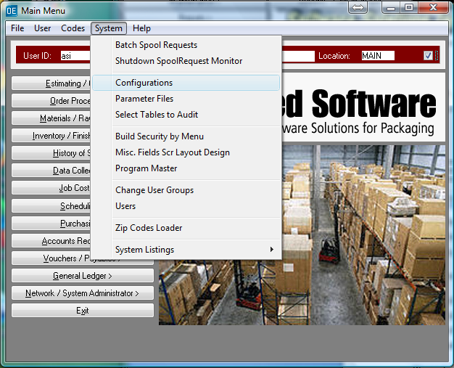

Simply hit the Update button, and specify an “Audit Directory” that will be accessible to all users. If you don’t specify a full path, the subdirectory used will be the “RCODE” directory where the ASI program files are stored.

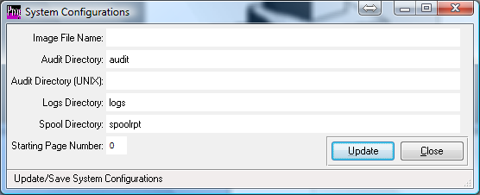

Once you establish an audit directory to store your output files, you must then select the database tables that you would like to audit. These tables may not all have user-friendly names, so please contact ASI Support for guidance.

The tables can be selected within the “Select Tables to Audit” utility from the “System” menu of the “Main Menu”:

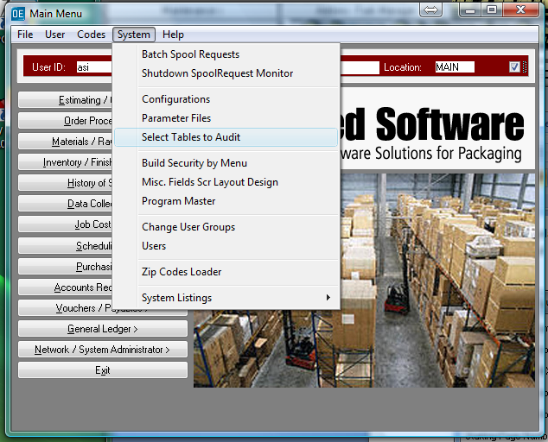

The left hand side of the screens lists all databases and their corresponding tables. To activate a particular table, simply highlight the table and hit the “Add” button. This will move the table to the list on the right titled “Tables to Audit”.

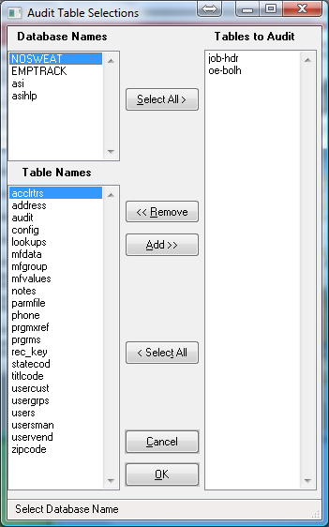

# Accessing the Audit Trail Files

Once activated using the previously outlined steps, the audit trails will be begin to be generated in the specified audit folder.

The filenames of the audited data is simply a date and time stamp of when the information was captured.

If the file was an update audit the data will look something like this:

"UPDATE" "Q:\Data\Progress\asi10test\db1010\asi" "oe-bolh" "asi" 09/02/14 64472

"001" "MAIN" 1 5284 09/02/14 "TACOBELL" 0 "" 0 09/01/14 "**TRUCK**" "" no no ? 0 "" "" "" "" 0 no no 8000 9181 10 20 0 0 "TACOBELL" 4 "" 0 0 no "asi" "P" "0902201409376482" "" 09/02/14 48922 "R" 0 8058 "" "" 0 no no 0 "" "" "" "" "" "" "" "" "" "" 0 "" 0 "" 0 "" "" 09/02/14 "" "" "" "" ? 0 "" "" "" "" "" "" 0 0 0 0 0 0 0 0 0 0

"001" "MAIN" 1 5284 09/02/14 "TACOBELL" 0 "" 0 09/01/14 "**CC**" "" no no ? 0 "" "" "" "" 0 no no 8000 9181 10 .8 0 0 "TACOBELL" 4 "" 0 0 no "asi" "P" "0902201409376482" "" 09/02/14 48922 "R" 0 8058 "" "" 0 no no 0 "" "" "" "" "" "" "" "" "" "" 0 "" 0 "" 0 "" "" 09/02/14 "" "" "" "" ? 0 "" "" "" "" "" "" 0 0 0 0 0 0 0 0 0 0

The file contains the user name and date (in blue above) as well as details for the record itself. The field data shown is actually a space delimited listing of all of the fields, first for the original record, and second for record after the change was made. In the example above, the carrier “TRUCK” was changed to “CC”. There may be multiple changes captured within one file.

If the file was a deletion audit, the data will look something like this:

"DELETE" "Q:\Data\Progress\asi10test\db1010\asi" "oe-bolh" "asi" 09/02/14 64553

"001" "MAIN" 1 5284 09/02/14 "TACOBELL" 0 "" 0 09/01/14 "CC" "" no no ? 0 "" "" "" "" 0 no no 8000 9181 0 .8 0 0 "TACOBELL" 4 "" 0 0 no "asi" "P" "0902201409376482" "" 09/02/14 64553 "R" 0 8058 "" "" 0 no no 0 "" "" "" "" "" "" "" "" "" "" 0 "" 0 "" 0 "" "" 09/02/14 "" "" "" "" ? 0 "" "" "" "" "" "" 0 0 0 0 0 0 0 0 0 0

The field data shown is actually a space delimited listing of all of the fields for the record that was deleted.